PROJECT 1

EEPROM-Based Temperature Logger with LCD Display
Using ATmega328P and TMP36 Sensor

Project Report
Submitted by: Sakshi
Sonawane
Platform:
Tinkercad (Online Simulation)
Programming Language:
Embedded C (Register-Level Programming)
Microcontroller:
ATmega328P (Arduino Uno)

Introduction

Temperature monitoring is a fundamental requirement in many embedded applications such as industrial automation, environmental monitoring, and safety systems. This project demonstrates the design and simulation of an embedded system that measures ambient temperature using a TMP36 sensor, processes the data using the inbuilt ADC of ATmega328P, and displays the temperature on a 16×2 LCD.
To enhance system reliability, EEPROM memory is used to store minimum and maximum temperature values, ensuring data retention even after power loss.

Project Objectives


- Interface ATmega328P with TMP36 temperature sensor

- Read temperature using inbuilt ADC every one second

- Display temperature data on 16×2 LCD

- Implement logic using Embedded C (non-Arduino style)

- Simulate the complete system using Tinkercad

System Overview

The system consists of a temperature sensor connected to the ADC input of ATmega328P. The microcontroller reads analog temperature data every one second, converts it into degree Celsius, and displays it on an LCD. EEPROM memory is used to track minimum and maximum temperature values.

System Components (Simulation-Based)

Component | Description
1. ATmega328P | Simulated microcontroller in Tinkercad
2. TMP36 | Simulated temperature sensor
3. LCD 16×2 | Simulated display module
4. EEPROM | Internal EEPROM (simulated)
5. Power Supply | Virtual 5V supply

Software Tools Used

- Tinkercad – Online circuit simulation
- Arduino IDE – Code compilation and upload
- C – Register-level programming

Working Principle

The TMP36 sensor generates an analog voltage proportional to temperature. This voltage is read by the inbuilt ADC of ATmega328P every one second. The ADC value is converted into temperature using a mathematical formula. The current temperature is displayed on the LCD.
The system compares the current temperature with stored minimum and maximum values. If required, EEPROM memory is updated accordingly.

Design

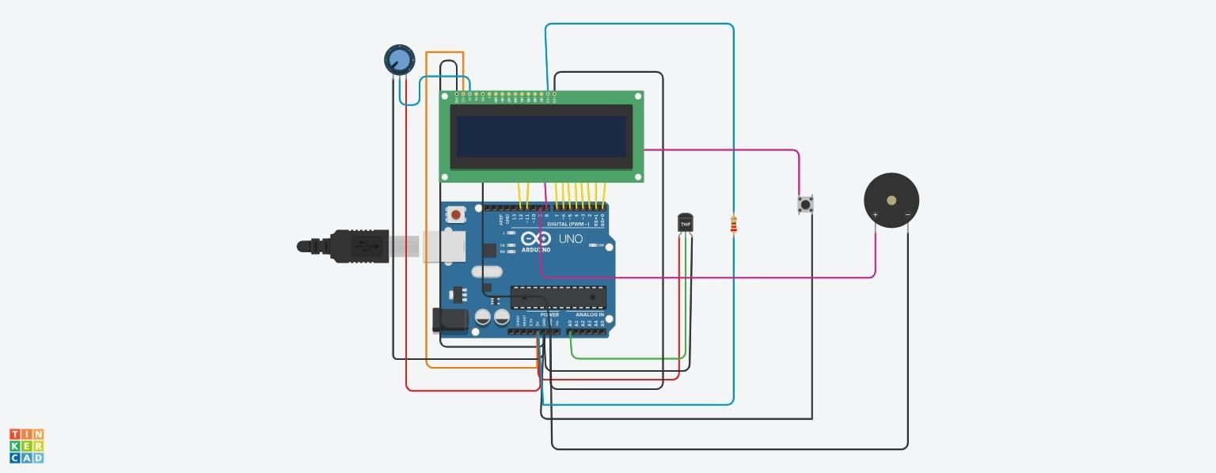

Source Code

#include <LiquidCrystal.h>
#include <EEPROM.h>

// For 8-bit mode: RS, EN, D0, D1, D2, D3, D4, D5, D6, D7
LiquidCrystal lcd(12, 11, 0, 1, 2, 3, 4, 5, 6, 7);

// Other pins (adjusted because D2, D3 are now used by LCD)
#define TMP36_PIN A0
#define BUTTON_PIN 8 // Changed from D2 to D8
#define BUZZER_PIN 9 // Changed from D3 to D9
#define TEMP_LIMIT 30.0

void setup() {
// Initialize 8-bit LCD (16 chars, 2 lines)
lcd.begin(16, 2);

pinMode(BUTTON_PIN, INPUT_PULLUP);
pinMode(BUZZER_PIN, OUTPUT);

// Initialize EEPROM
if (EEPROM.read(0) == 0xFF) EEPROM.write(0, 100); // Min
if (EEPROM.read(1) == 0xFF) EEPROM.write(1, 0); // Max

lcd.print("8-bit Mode Ready");
delay(1000);
}

void loop() {
// Read temperature
int adc = analogRead(TMP36_PIN);
float voltage = adc * (5.0 / 1023.0);
float tempC = (voltage - 0.5) * 100.0;

// Check button
if (digitalRead(BUTTON_PIN) == LOW) {
EEPROM.write(0, (int)tempC);
EEPROM.write(1, (int)tempC);
delay(500);
}

// Update Min/Max
int minTemp = EEPROM.read(0);
int maxTemp = EEPROM.read(1);

if (tempC < minTemp) EEPROM.write(0, (int)tempC);
if (tempC > maxTemp) EEPROM.write(1, (int)tempC);

// Buzzer control
digitalWrite(BUZZER_PIN, tempC > TEMP_LIMIT ? HIGH : LOW);

// Display on LCD
lcd.clear();
lcd.setCursor(0, 0);
lcd.print("Temp: ");
lcd.print(tempC, 1);
lcd.print("C");
lcd.setCursor(0, 1);
lcd.print("Min:");
lcd.print(minTemp);
lcd.print(" Max:");
lcd.print(maxTemp);
delay(1000);
}

Result

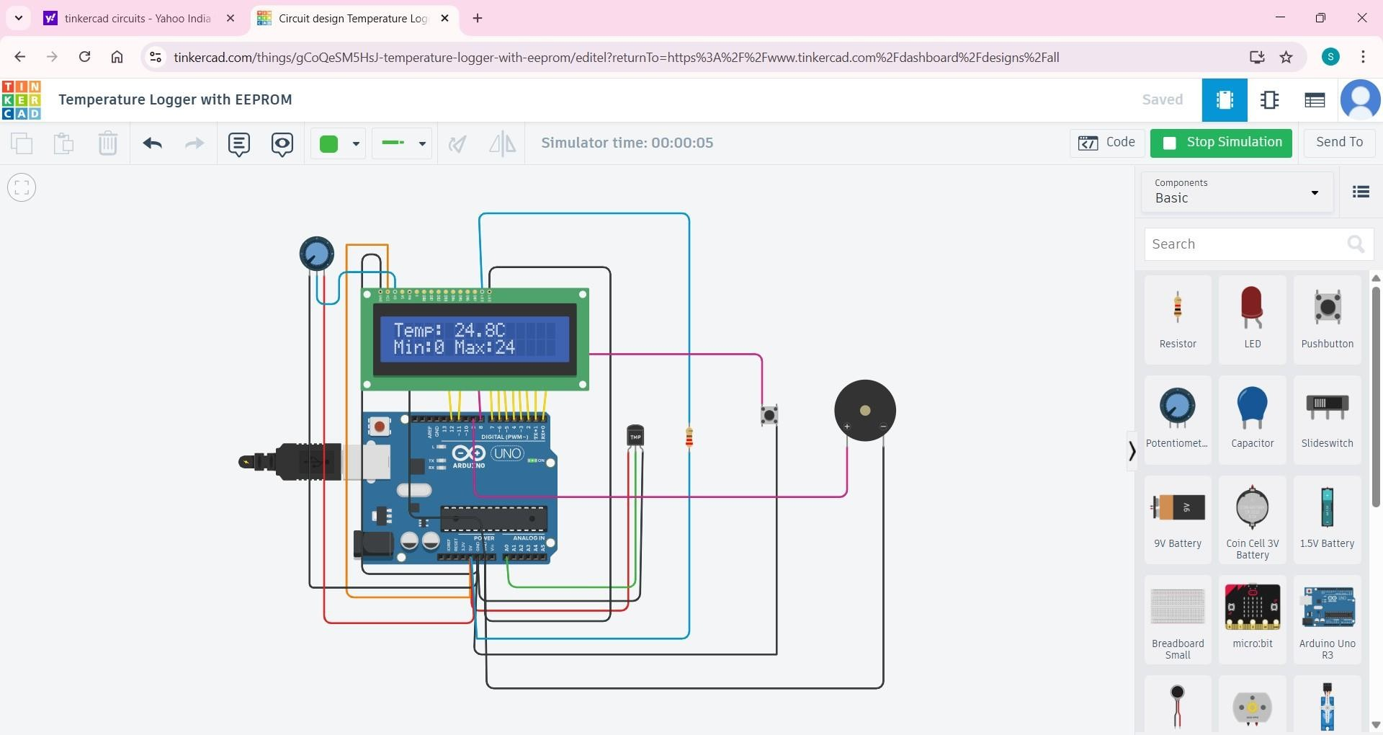

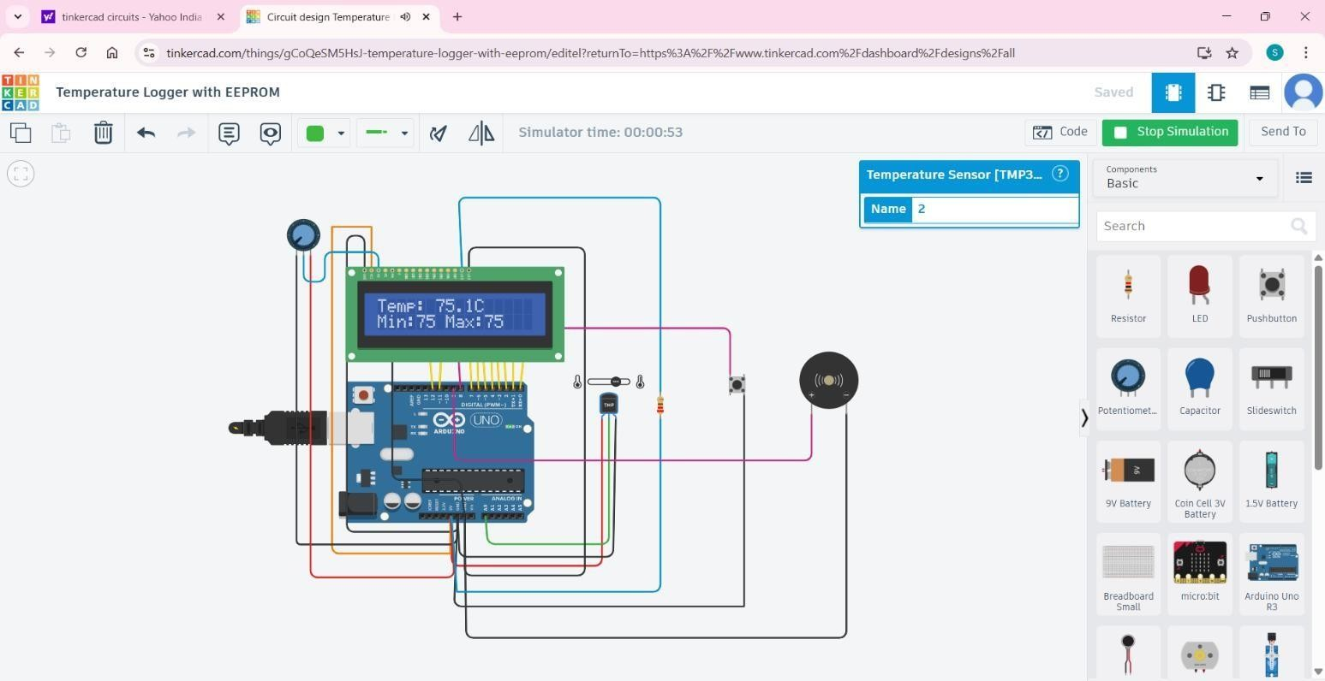

Video link :- https://drive.google.com/file/d/1gIs6eTpTTlZg6waXlNaqyIGbPXeVu4no/view?usp=drivesdk

Applications

- Environmental monitoring systems
- Industrial automation
- Embedded learning projects
- Safety and control systems

Advantages

- Non-volatile data storage
- Low power consumption
- Simple and reliable design
- Industry-relevant implementation

Limitations

- Limited EEPROM write cycles
- Single sensor monitoring
- No wireless data transmission

Future Scope

- External EEPROM or SD card logging
- Serial or IoT-based data visualization
- Multi-sensor expansion
- Graphical LCD display

Conclusion

This project successfully demonstrates an embedded temperature monitoring system using ATmega328P and TMP36 sensor. The use of EEPROM enhances reliability by ensuring persistent storage of temperature data. The project meets all specified requirements and follows industry-standard embedded system design practices.

Tinkercad Link :- https://www.tinkercad.com/things/gCoQeSM5HsJ-temperature-loggerwith-eeprom

